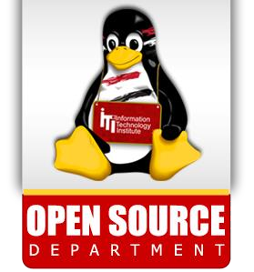

**2**

**Lab**



1. Copy the rm program to your home directory, naming it myrm, grant set-uid permission, what happens if one of the users starts your ~username/myrm to edit one of your own files?

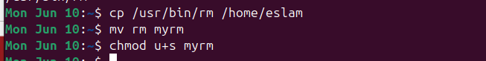

1. What is the difference between the set-uid and set-gid?

**Set-uid:** is a special permission that allows a user to execute a file with the permissions of the file's owner rather than the user who is executing it

set-gid: is a special permission that allows a user to execute a file with the permissions of the file's group rather than the user's own group.

1. Create a directory with sticky-bit and write permissions on, grant all the users to access the directory, will any user be able to create and delete files from the directory?

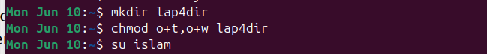

1. Create a directory with set-gid permission, what do you notice when you create a new file or a directory?

